

CS5224 Group Project Report

Full Name | Matriculation Number
Muhammad Fariz Bin Mohammad Yusri | A0249554U
Ng Jun Wei | A0252142U
Peng Siang Ling | A0319335A
Rasyiqah binte Shaik Mohamed Salim | A0204205Y
Tan Hua Swen | A0216984R
Tseng, Yung Yi | A0318929M

(1) Motivation/Business Case – problem statement and formulation, purpose and target users of your service, comparison with other services, etc.
(2) Business Model – will this be free or revenue-generating? If so, how? Compare and justify your SaaS with an on-premise implementation of the same in the final report.
(3) Architecture & Implementation – discuss your SaaS in more detail, such as, design, algorithms, implementation, requirements, user journey, etc. In the preliminary report, this can be an initial plan.
(4) Evaluation – how do you know your SaaS works well? Discuss how you evaluated your SaaS. In the preliminary report, this can be an evaluation plan.
(5) Conclusion & Future work (if any).
(6) Code Explanation (required) – similar to a README, this contains information on your code base. It should also include a public URL which links to your code base. This URL should be accessible until the time your marks and feedback are released. This section is not needed for the preliminary report.

2. Business Model
2.X Competitor Cost Comparison (on-cloud)
Dimension | RetailMind | SageMaker AI | RoboFlow
Pricing model | Tiered subscription + usage quotas for overages | Pay-as-you-use | Subscription + credit system for overages
Entry cost | Free tier available for trial users and micro retailers | Free tier usage available for the first 2 months, with additional charges based on vCPU and memory usage | Free tier available, but service is limited to vision models only
Cost predictability | High  - Fixed monthly subscription  - Transparent costs for potential overages before usage | Low  - Session hours and processing/ training hours are charged separately → easy to overspend | Medium  - Base subscription tier pricings are predictable  - Auto-billing for actual resources and overages used during training
Representative cost example | Growth plan  - 3 users  - 100 jobs per month  - (insert cost) | Pay-per-use  - 3 data scientists; 1 notebook instance, 2 hours per day, 20 days per month, 6 training jobs per month  - $9.67 base cost per month | Core plan  - 3 users  - 15 credits per month  - $99 per month
Target domain | Retail SME analytics | General-purpose ML  - Can be used in any domain, but requires data preparation and knowledge of the AWS ecosystem | Computer vision models only
Technical barrier | Low  - Chatbot-driven framing → no ML expertise required | Medium  - No-code interface, but users need to handle data preparation on their own and know how to operate within AWS | High  - Add and annotate your own data  - Build your own workflow  - Deploy your own model
Multi-user support | Up to 3 (Growth plan)  Unlimited (Pro plan) | Per-user session charges  - Cost scales according to team size | Plan dependent  - 2 users (Free/public)  - 3 users (Core)  - Unlimited (Enterprise)
Data residency | Singapore region (ap-southeast-1)  - Data stays in-country | Configurable, but requires explicit setup in AWS before usage due to broader AWS ecosystem dependencies | Not configurable for most plans  - US-hosted by default
Idle cost | Near zero  - Serverless architecture scales to zero when not in use | Zero if logged out  - If analysts forget to log out or leave the session running, per-hour session fees are charged | Fixed monthly base subscription regardless of usage

(3) Architecture & Implementation – discuss your SaaS in more detail, such as, design, algorithms, implementation, requirements, user journey, etc. In the preliminary report, this can be an initial plan.
(4) Evaluation – how do you know your SaaS works well? Discuss how you evaluated your SaaS. In the preliminary report, this can be an evaluation plan.

3. Architecture & Implementation
Our SaaS platform, RetailMind, leverages a serverless-first architecture deployed on AWS infrastructure within the Asia Pacific (Singapore) region. The system is designed with multi-availability zone replication to ensure high availability while maintaining data residency within Singapore's borders for compliance and security requirements/concerns.
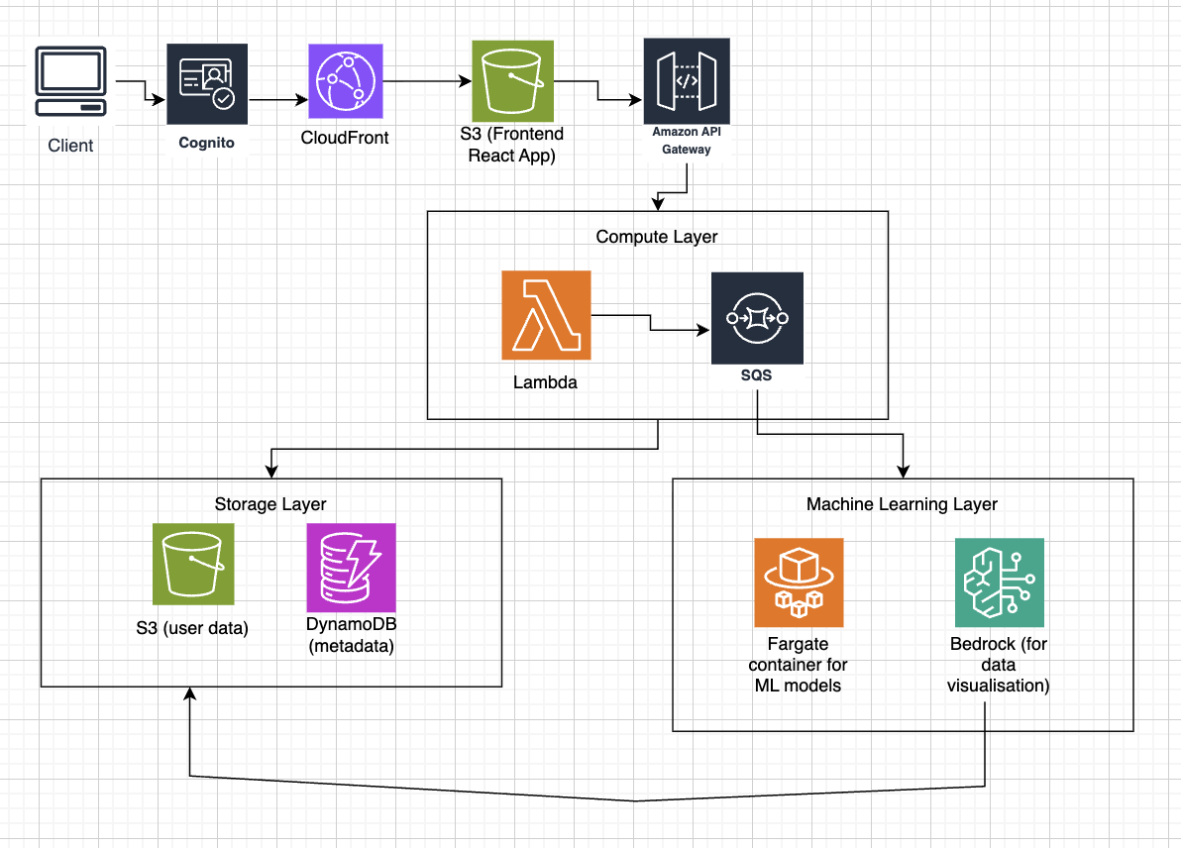
Figure X: AWS Cloud Architecture
3.1 System Design and Architectural Rationale
We utilise a serverless architecture for two key reasons: Firstly, as we are first starting with this application, metrics to predict usage and scaling are unreliable, and it is difficult for us to estimate baseline traffic levels or peak workloads. A serverless platform lets us scale compute resources on demand and allows us to handle sudden spikes without manual configuration. Secondly, a serverless application is ideal for our business solution as it is event-driven workloads. We do not require continuous 24/7 compute resources as our ML operations (uploading data, requesting model training and generating visualisation) occur only when triggered by user actions.
We may decide to migrate to a server-based architecture once we have established usage metrics and a baseline usage rate that helps us to generate autoscaling policies on EC2, as well as get a better estimate of cost metrics to compare the cost of serverless to server for this decision.
3.1.1 Core Components and Services
Table X: Core Services
Service | Primary Function | Rationale for Selection
Amazon Cognito | User authentication and authorisation | Built-in security, scalability, and compliance
CloudFront + S3 | Frontend React app delivery (static hosting) | Better control over configuration and costs
API Gateway | Single HTTPs entry point and routes requests to lambda functions | Centralized security, throttling, and monitoring
AWS Lambda | Backend API layer (this contains all our application routes and logic) | Cost-effective for short-duration requests
AWS Step Functions | ML Workflow Orchestration | Stateful management of ML pipelines with built-in retry logic
AWS Fargate | Containerised python workers for ML model training (>15 mins job) | No server management, automatic scaling, pay-per-use
Amazon S3 | Store user data, datasets and others (dashboard, job records) | Virtually unlimited scalability, integrated with AWS ecosystem
DynamoDB | Metadata for datasets, user preferences, system configuration | NoSQL flexibility, serverless scaling, lower latency for metadata queries
Amazon Bedrock | Data visualisation and conversational AI interface | Regional availability with integrated AWS security

3.2 Architecture Implementation
The overall architecture is event-driven, enabling asynchronous processing to handle long-running ML training tasks without blocking the user interface. The frontend uses React webpage served via CloudFront, with backend logic handled by AWS Lambda acting as the API layer, where API calls are routed through Amazon API Gateway. Users will authenticate through Amazon Cognito. We separate the data storage into Amazon S3 for user-uploaded datasets and ML model artefacts (eg. plots, learned weights/parameters..) as well as Amazon DynamoDB for structured metadata. We use AWS Fargate containers to handle long-running ML training jobs which will be triggered via Amazon SQS.

AWS Lambda serves as our backend API layer, this allows us to auto-scale and have a pay-per-use flexibility into our application. This keeps our costs low as we do not need a server. As our application may run long-running ML models that exceed 15 minutes, we instead run ML model training jobs as python containers (scikit-learn) on AWS Fargate, which will be triggered and managed by AWS Step Functions. Step Functions orchestrates the task lifecycle, ensuring that the Fargate container is provisioned, executed, and its results are logged before transitioning to the next state.This allows us to scale automatically (and to zero if idle), which may be useful as this is a new application and we are uncertain about potential traffic flows. As Lambda and Fargate (used purely as a background ML worker) are scaled on demand, we do not need a Load Balancer unlike with running fixed servers.

4. Evaluation of the cloud architecture
To ensure that our SaaS product can bridge the data capability gap for SMEs, its performance must be efficient and also cost-effective. Our product’s AWS-based architecture can be evaluated with four key metrics, which will be discussed in Sections 6.1 to 6.4.

4.1. Architecture Quality
As we are utilising a serverless-first design, we should assess the integrity and efficiency of the platform compared to traditional always-on servers. We identify the following performance metrics to evaluate our architecture performance:
- API latency: Time for API Gateway and lambda to respond
- Chatbot and Visualisation response time: Monitoring the end-to-end duration for AWS Nova 2 Lite to generate natural language insights and visualization metadata.
- ML job startup time: Time between job request and Fargate task start
Use CloudWatch for monitoring above performances.

4.2. Scalability and Reliability
In order for retail SMEs to rely on the platform for daily operations, the infrastructure must accommodate for growth and maintain high reliability. The platform’s reliability will ensure the long-term retention of users. We will evaluate scalability by testing the system on different test scenarios:

Scenario | Concurrent Users | Training Jobs
Light load | 10 users | 10 jobs
Medium load | 100 users | 100 jobs
Heavy load | 1000 users | 500 jobs

With each scenario, we track the metrics mentioned earlier in architecture quality and map onto a graph. A sign of good scalability should observe that lambda response time remain stable, response times remain consistent and Fargate tasks are successfully orchestrated according to the workflow demand.
To evaluate the platform’s reliability, we will conduct simulated disruptions within a staged environment. This involves disrupting specific infrastructure components, such as terminating an active AWS Fargate ML worker in the middle of a task or by simulating a complete outage of an AWS Availability Zone (AZ).
The platform is reliable if the conversational interface (chatbot) remains fully accessible and seamlessly reroutes traffic to a healthy AZ without dropping user sessions. Additionally, any disrupted Machine Learning jobs are not lost but rather caught by the AWS Step Functions error handling logic, which can then trigger a retry of the Fargate worker. This ensures there is no sudden data loss or downtime during physical hardware outages.

4.x.AWS Infrastructure Cost Breakdown
Below is an estimation of the cost of our cloud service
Assumptions:
- Each user completes 1 project per month
- Each project = 1 job
  - 15 API calls
    - Stage 1: login + upload = 2 calls
    - Stage 2: use case selection = 2 calls
    - Stage 3: problem refinement = 2 calls
    - Stage 4: dashboard load = 2 calls
    - Stage 5: trigger training + poll job status = 3 calls
    - Stage 6: fetch cost/quota = 2 calls
    - Stage 7: fetch results = 2 calls
    - Total = ~15 calls
  - 1 Fargate training job
    - From model architecture
  - 7 Bedrock calls
    - Stage 3 problem refinement: ~3 back-and-forth messages
    - Stage 4 AI-generated insights: ~2 calls
    - Stage 7 results interpretation: ~2 calls
    - Total = ~7 calls
  - ~ 15MB data stored (user CSV + model artefacts)
    - Raw CSV (sales/inventory data for a small retailer): ~10MB
    - model.pkl artefact (sklearn/xgboost): ~3MB
    - Metrics and plots saved to S3: ~2MB
    - Total = ~15MB
  - 30 DynamoDB reads + 10 writes
    - Reads: each of the 15 API calls that touch DB does ~2 reads on average = 30
    - Writes: project creation, job record, chat messages saved, result stored = ~10 writes
Service | Light load | Medium load | Heavy load | Remarks/Calculation basis
 | 10 users, 10 jobs | 100 users, 100 jobs | 1000 users, 1000 jobs
VPC | 0 | 0 | 0 | No NAT gateway used
DynamoDB | 0  300 reads + 100 writes per month → within free tier | 0  3000 reads + 1000 writes per month → within free tier | 0  30000 reads + 10000 writes per month = ~ 0.01 reads per sec on average → within free tier | Free tier provides 25 WCU and 25 RCU with 25 GB storage  Beyond:  Reads: jobs × 30 × $0.0000001425  Writes: jobs × 10 × $0.00000071  0.285 USD per GB of storage
S3 | ~$0.50  (1-2 GB)  Storage: 10×15MB = 0.15GB × $0.025 = $0.004  Requests: 20 PUTs + 50 GETs → ~$0.00012  Total: $0.00412 | ~$1-2  (few GBs)  Storage: 100×15MB = 1.5GB × $0.025 = $0.038  Requests: 200 PUTs + 500 GETs → ~ $0.0012  Total: $0.0392 | $3-5  (several GBs)  Storage: 1,000×15MB = 15GB × $0.025 = $0.375  Requests: 2000 PUTs + 5000 GETs → ~$0.012  Total: $0.387 | 3 Standard costs ~$0.023/GB/month in ap-southeast-1  Storage: jobs × 15MB = total GB  $0.025/GB/month  PUT: $0.000005/request  GET: $0.0000004/request  ~2 PUTs + 5 GETs per project
Lambda | 0  150 req → still within 1M free tier | 0  1500 req → still within 1M free tier | $0-1  15,000 req → still within 1M free tier  Compute: 15K × 0.5GB × 1s = 7,500 GB-s → within 400K free | Requests: users × 15 calls/project  Free tier: 1M req/month (permanent)  Beyond: $0.000167/1K req  Compute: avg 512MB, 1s/call  Free tier: 400K GB-s/month  Beyond: $0.0000167/GB-s
API Gateway | 150 × $0.00000425  = ~ $0.001 | 1,500 × $0.00000425  = ~ $0.01 | 15,000 × $0.00000425  = $0.06 | jobs × 15 calls × $0.00000425/call  = $4.25 per million requests
Cognito | 0  10 MAUs → within 10,000 free | 0  100 MAUs → within 10,000 free | 0  1000 MAUs → within 10,000 free | Per monthly active user (MAU)  Free tier: 10,000 MAUs  Beyond: $0.0055/MAU
CloudFront | 0  Well within the 1TB free tier | 0  Well within the 1TB free tier | $0-1  ~1,000MB = 1GB → within free tier | Static Next.js SPA ~1MB/session  First 1TB/month + 10M requests free  Heavily cached — repeat visits near zero
Step Functions | 0  10 × 6 = 60 → within 4,000 free | 0  100 × 6 = 600 → within 4,000 free | $0-1  1,000 × 6 = 6,000 transitions  6,000 − 4,000 = 2,000 billable  2,000 × $0.000025 = $0.05 | Transitions: jobs × 6 steps/job  Free tier: 4,000 transitions/month  Beyond: $0.000025/transition
ECS Fargate | 10 x $0.05  = ~$0.50 | 100 x $0.05  = ~$5 | 1000 x $0.05  = ~$5025 | $0.05/job  (from architecture diagram)  1 vCPU · 2GB · ~30 min/job  Scales to zero when idle
ECR | 2GB × $0.10  = ~$0.20 | 2GB × $0.10  = ~$0.10 | 2GB × $0.10  = ~$0.10 | ~2GB image stored all month  $0.10/GB/month storage  Layer caching = minimal transfer cost  Fixed regardless of job count
Bedrock | ~$2-5  10 × 7 × $0.001  = $0.07 | ~$8-10  100 × 7 × $0.001  = $0.70 | ~$30-80  1000 × 7 × $0.001  = $7 | jobs × 7 calls × $0.001/call  $1.00/M input tokens  $5.00/M output tokens  ~$0.001/call (from architecture diagram)
CloudWatch | 0  Log volume minimal → free tier | 0  Log volume minimal → free tier | $0-1  ~1,000 Lambda invocations → still well within 5GB free log tier | Free tier: 5GB log ingestion  3 dashboards/month free  10 custom metrics free  Beyond logs: $0.70/GB
Total | $5-8 | $15-20 | $60-120
Amazon SageMaker | Find cost breakdown |  |  | Price shown is for  ap-southeast-1  sc.t3.medium  2 vCPU, 4 GB  Cost: $0.063/hr

4.3. Security
Since the platform potentially processes confidential data from SMEs, proving the effectiveness of our security architecture is crucial to establishing and maintaining user trust. To evaluate whether the proposed SaaS security measures work as intended, we will subject the platform to rigorous vulnerability and boundary testing across three key areas:

Chatbot Vulnerability and Leak Testing | The conversational interface will be evaluated using prompt injection and boundary testing. This ensures the chatbot strictly prevents unauthorized data leaks, ensuring that it only retrieves and discusses data explicitly tied to the current authenticated user's session.
Cross-Tenant Authorization Audits | The effectiveness of Amazon Cognito and our multi-tenant separation can be evaluated by role-based access testing. This involves simulating scenarios where one authenticated SME attempts to access, view, or query the datasets and predictive models of other SMEs, ensuring that strict data isolation holds up under pressure.
Network Isolation Testing | Conduct regular vulnerability scanning and external penetration testing to verify that our private subnets are fully secure. This ensures that backend systems (storage and ML workers) completely block direct public internet access and strictly route allowable traffic through the API Gateway.

4.4. Business-level Key Performance Indexes (KPIs)
The SaaS performance can be measured by its direct impact on business viability and operational success of its users. KPIs allow the platform to quantify how effectively it is closing the compatibility gap for retail SMEs. By monitoring these indicators, the system ensures that infrastructure costs are maintained and that the user experience is of top quality.

Table X: KPIs to ensure Maximum Impact of the Proposed SaaS
Churn rate | This KPI monitors the rate at which SMEs cancel their subscriptions. By tracking when users leave, the system can identify technical or operational bottlenecks that may be driving users to opt out of using the product.
Cost Per Tenant (CPT) | The cloud compute and storage expenditures are tracked per user across the “Free”, “Growth”, and “Pro” tiers to ensure that the pricing strategy remains profitable and sustainable. The architecture can then be scaled economically to ensure that low-cost entry points are viable (i.e “Growth” tier).
Time-to-Insight | The system measures the end-to-end duration from an SME’s initial problem alignment via the chatbot, to the delivery of the predictive models or business suggestions. Optimization of the pipeline can be carried out to deliver predictive models/outputs faster.
Feature Adoption Rates | This KPI checks which analytical model or chatbot tools are used the most often. Any future investments towards improving the product will always be focused on the real challenges faced by the retail SMEs, making sure that the product is relevant always.

(– Rework on 4.4 (or business evaluation) –)
To quantify RetailMind’s competitive advantage for retail SMEs, we benchmarked our platform against 2 industry baselines: Roboflow, and Amazon Sagemaker. Our user evaluation focused on 3 main performance scenarios having the goal to reduce technical barriers and accelerate decision-making. We conducted comparative testing with x users across 3 key metrics: Zero-training time-to-insight (TTI), Intent Alignment, and Recommendation Actionability. Table x and Table y summarizes the quantitative test metrics conducted and the results.

Table x: Test Metrics and Definition
Test Metric | Definition
Zero-training time-to-insight | The time required for a new user to go from login to their first insight without a manual to guide through.
Intent Alignment | The ability of the chatbot to understand business intent and provide reasonable predictive outputs. Tested via 3 distinct business queries, scoring from 0 (does not understand) to 5 (fully understand and provide reasonable outputs)
Recommendation Actionability | To what extent does the results include concrete, actionable business suggestions. (i.e., “Suggested Next Steps” and “Key Business Takeaways”). Content analysis scored from 0 (no actions) to 5 (fully expressed suggestions).

Table y: Quantitative Test Metrics Results on x users
Quantitative Test Metric | RetailMind | Roboflow | Amazon SageMaker
Zero-training time-to-insight | ~ 09:30 min | ~ 08:10 min | ~ 09:15 min
Intent Alignment | 4.25/5 | 2.6/5 | 5/5  *Requires technical background to achieve result
Recommendation Actionability | 4.5/5 | 0/5 | 4/5

［To be Refined] We also assessed some qualitative aspects beyond the quantitative results from our testers. This provides a significant stance on the reason why RetailMind is the optimal choice for our target users:
- Expertise gap bridging: Although SageMaker achieves high intent alignment, it requires SQL coding background for data preprocessing, as well as cloud knowledge. RetailMind allows a non-technical person to complete the preprocessing stage simply through clicking a button and interacting with the chatbot to “learn” within the process.
- Business

